Title Here: ALISE 2018 Submission Template [Word]

Author's Nameª [email], Author's Name^{b} [email], and Author Nameª [email]
ª affiliation and address
^{b} affiliation and address

ABSTRACT
[Required: A brief indicative abstract approximately 100 words.]
TOPICS:
[Required: maximum 5 topics from ALISE Research Taxonomy (2016) At https://ali.memberclicks.net/research-taxonomy; separate with semicolon ";"]
INSTRUCTION
Beginning of the body text here. This template is required for your final submission if will be published in the procceedings. The final revised submission must incorporate reviewers suggestions and comply with the format defined in this template.
This template is designed for the "Proceedings of the Association for Library and Information Science Education Annual Conference: ALISE 2018." (ISSN 2573-2269) The content of the submissions should follow the relevant call for proposals.
Open access. This proceedings will be published as one volume to be deposited into The Illinois Digital Environment for Access to Learning and Scholarship (IDEALS). The proceedings is licensed under the Creative Commons Attribution-NonCommercial-ShareAlike 4.0 International License.
For authors. By submitting your work for conference presentations, you agree that the published version of your work in the proceedings will be free access to all users under the Creative Commons Attribution-NonCommercial-ShareAlike 4.0 International License.
To submit your final revised version for the proceedings, the structured format with headings must be followed as described in the following section. Name your file using the submission number such as paper579.docx, paper579.pdf, panel975.doc, and paenl975.pdf (both doc or docx files are acceptable). Upload to the ConfTool two files of your final submission: a word file and a pdf file as the field indicated. The submission must be loaded no later than October 15, 2017.
ABOUT THE TEMPLATE
This template adopts ANSI/NISO Z39.14-1997 (R2015) Guidelines for Abstracts. The body text of the proposal should be structured similar to ANSI/NISO Z39.14 Appendix A: I. Informative Abstracts, Example I Structured abstract and use APA Level 4 Headings (https://owl.english.purdue.edu/owl/resource/560/16)
This template provides two levels of headings: (1) section headings use Times New Roman bold uppercase font (e.g., FORMATTING); (2) subsection headings are placed at the beginning of the paragraph (e.g., About the template)
This template has predefined style items visible from the Home Tab, Styles toolbar (Figure 1). You can use it to format Body text, Section heading, Subsection Heading, TableCaption, ImageCaption and Cited. Just select the texts and select the intented style for the texts. Figure 1 shows the Body text was selected. (see the specifics of thes style elment in next section)
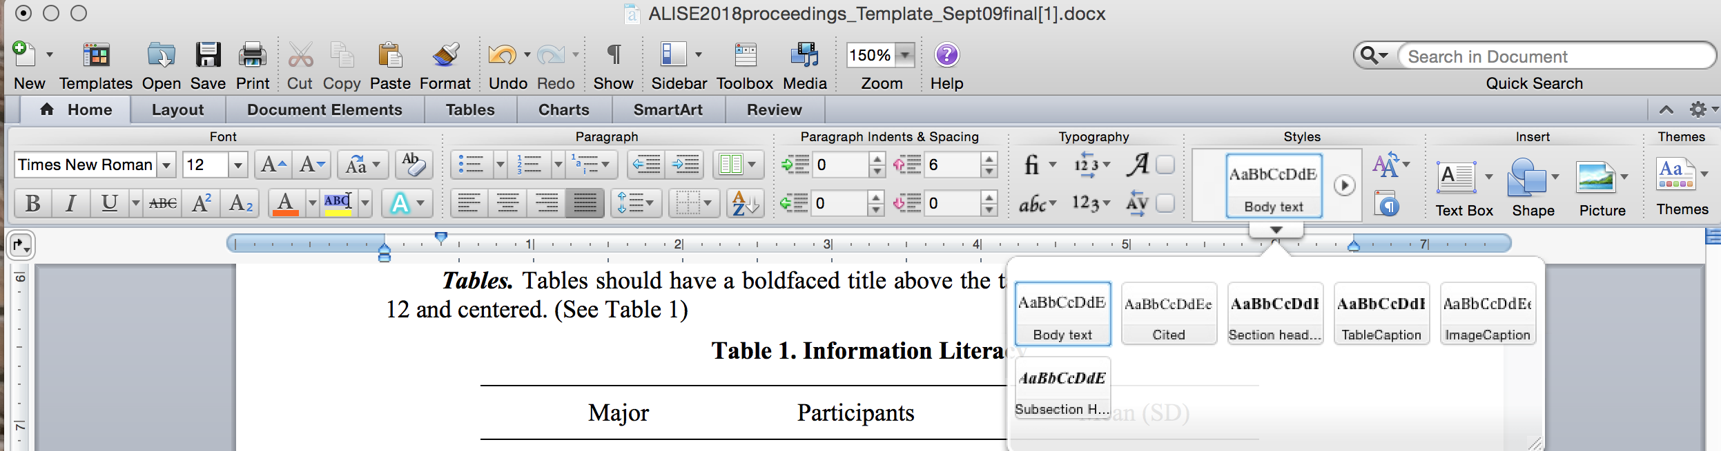
Figure 1. MicroSoft Word Quick Style Gallary
FORMAT SPECIFICS
Size, margins and running headers. All pages size should be US Letter (8.5" x 11"), justified alignment. Set top and bottom margins for 1.2" and left and right margins for 1". The running header is on the top of the page. Do not add page numbering. The header is omitted on the page with the title.
Fonts and spacing. The title is set for Times boldfaced font size 18. The section headings are set for Times New Room uppercase, bold, and 12 point. To achieve the 12-point interline spacing, the space before the section heading is set to 12 point; the space after the section heading is set to 6 point. Spacing for before and after paragraphs is set to 6 point.
The text body uses Times New Roman font size 12 point and single spacing. Do not add extra lines between paragraphs or sections.
Tables. Tables should have a boldfaced title above the table. Use Times New Roman, size 12 and centered. (See Table 1)
Table 1. Information Literacy
Major | Participants | Mean (SD)
English | 1,061 | 3.5 (1.1)
Math | 569 | 3.7 (1.5)
Images. For images, use boldfaced caption (size 12) with appropriate numbering. Caption is placed below the image and centered (Figure 1). For smaller images, wrap text left or right, or both sides.

Citation style. Use APA style in-text Author-Year citation format. For multiple authors, list up to five authors. Use comma to separate last names, and the word "and" between the last two authors within the text and use ampersand in the parentheses. For examples,
Figure 2. Caption Here Below Image
... A study by Bilal and Gwizdka (2016) reports ...
or
This finding has been reported (Bilal & Gwizdka, 2016)
ACKNOWLEDGEMENTS
The authors wish to thank [funding, individuals, ...]

REFERENCES
ANSI/NISO Z39.14-1997 (R2015) http://www.niso.org/apps/group_public/download.php/14601/Z39-14-1997_r2015.pdf
Bates, M.J. (2016). Information and the Information Professions. Berkeley: Ketchikan Press.
Bilal, D., & Gwizdka, J. (2016). Children's eye fixations on Google search results. [Poster]. In A. Grove, et al. (Eds.), Proceedings of the 79th Association for Information Science and Technology Annual Meeting. Retrieved February 14, 2017 from https://www.asist.org/files/meetings/am16/proceedings/openpage16.html
Ingwersen, P. (1999). Cognitive information retrieval. In M. Williams (Ed.), Annual review of information science and technology (ARIST), 34, 3-52.
Wang, P., You, S., Rath, M., & Wolfram, D. (2016). Open peer review in scientific publishing: A Web mining study of PeerJ authors and reviewers. Journal of Data and Information Science, 1(4), 60-80.
Zhang, Y. (In press). Understanding sustained use of online health communities from a self-determination perspective. Journal of the Association for Information Science & Technology (JASIST).

